Task – 26/09/2020

**Task: JSON response practical**

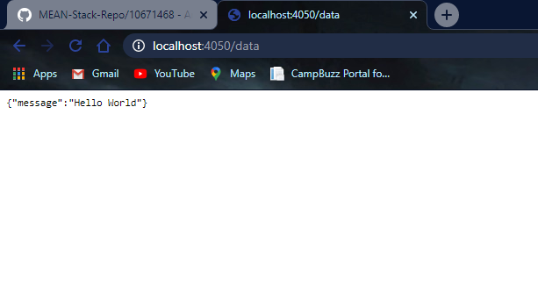

app.js  
-----------------------------------------------------------------------------------------------------------------------------------------

var http = require('http');

var server = http.createServer(function (req, res) {

    if (req.url == '/data') { //check the URL of the current request

            res.writeHead(200, { 'Content-Type': 'application/json' });

            res.write(JSON.stringify({ message: "Hello World"}));

            res.end();

    }

});

server.listen(4050);

console.log('Node.js web server at port 4050 is running..')

-----------------------------------------------------------------------------------------------------------------------------------------

console  
